
National Dog Bite Prevention

Week is May 20-26th

Know how to prevent a bite:
Use your common sense. Think about the actions that you may not like.



You would not like it if someone: Dogs also don’t like it when you:



Took your food Bother them when they are eating



Took your toys Take bones or toys out of their mouths



Bothered you when you sleep Wake them up


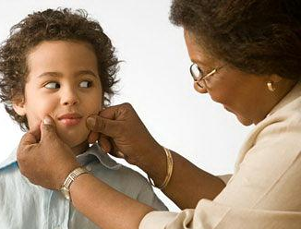
pestered you Grab their ears or tail



pinched your cheeks hug them-most dogs dislike this

yelled at you Shout at them-use your inside voice This information is brought to you by Avery Animal Hospital (614)876-5641

